

This is to certify that the names Stated below Has Successfully completed and developed

A Phonebook Maintenance Project.

|  |  |
| --- | --- |
| **Student1247998** | **ABDULAZIZ HUSSAINI TAIYE** |
| **Student1250677** | **RAJI TAOFEEK ABIODUN** |
| **Student1247996** | **ABDULAZIZ HASSAN KEHINDE** |

**DATE OF ISSUE:**

**06-JAN-2021.**

**Table of Content:**

* Acknowledgement
* Problem Definition
* Algorithm
* Source code and Screenshots.
* Conclusion.
* Appendix and References.
* User Manual

JAVA PROJECT DEVELOPMENTIn this chapter we are going to see the steps and the measures taken in the design and development of our “phonebook maintenance” project

**Requirements:**To develop A JAVA program for maintaining a phonebook ,which allows the user to “ADD”,”DELETE”,”MODIFY”,”SEARCH”,”COUNT” and “DISPLAY ALL RECORDS”.

**With the Software Requirements Below:**

* NetBeans IDE (Integrated Development Environment)
* NOTEPAD/NOTEPAD++
* Operating System --------- Windows 7, 8, 10, Mac.
* Tools Technologies ------- Java/ J2EE / .NET / C / C++.

**Hardware Requirements**

A minimum computer system that will help you access all the tools in the courses is a Pentium 166 or better. With at least 128 Megabytes of RAM.

**E-project design.**

**We** would be showing the design of our “phonebook-Maintenance” program. A project design is a strategic organization of ideas ,materials , and processes for the purpose of creating an efficient project.

**GRAPHICAL REPRESENTATION Of Phonebook Maintenance Application.**

**Create phonebookprojectmain.java**

**Countrecord.java**

**CONTACT.JAVA**

**PhoneBook.java**

**Display.java**

Run Code to Carry Commands of the Classes above. As it will save to text file.

SCREENSHOTS

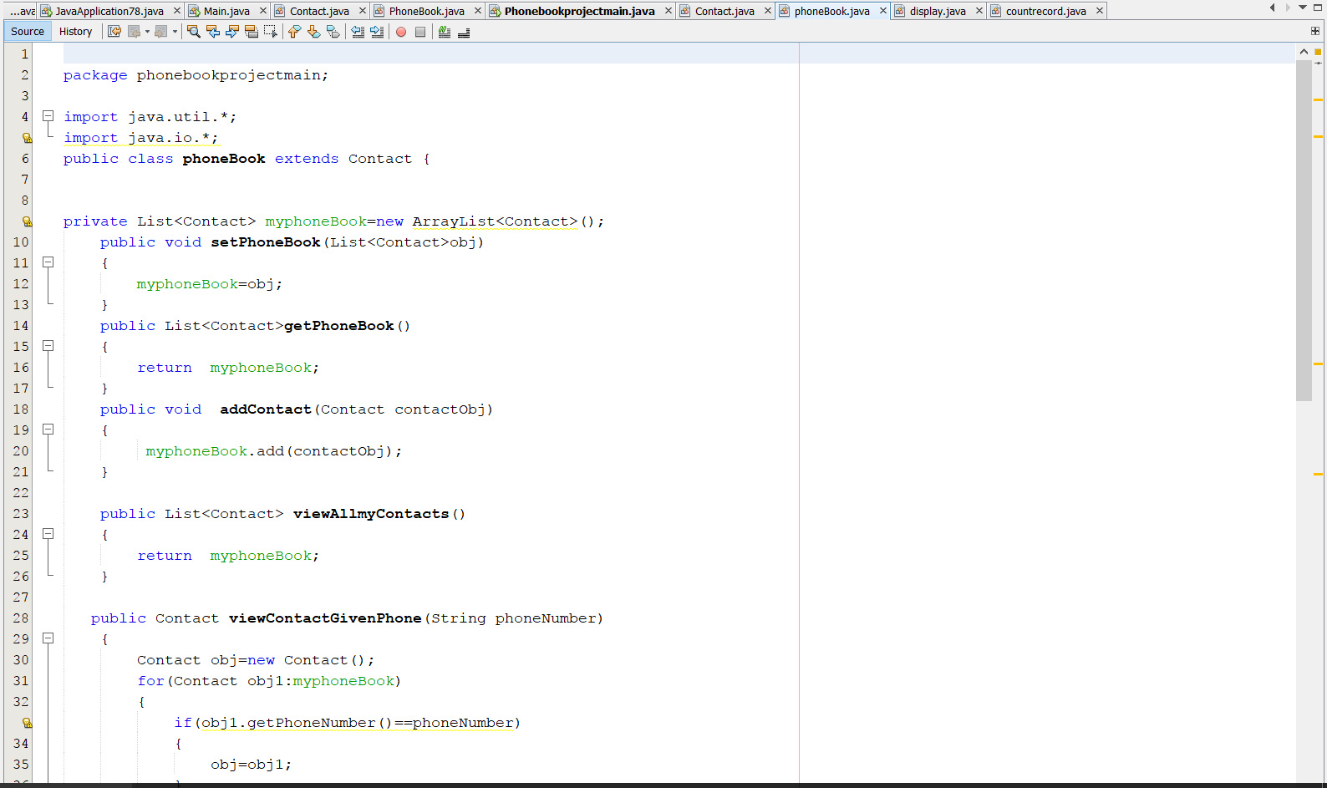

(MAIN-FILE)

**Create phonebookprojectmain.java**



**(SUB-CLASS)**

**PhoneBookclass.java**

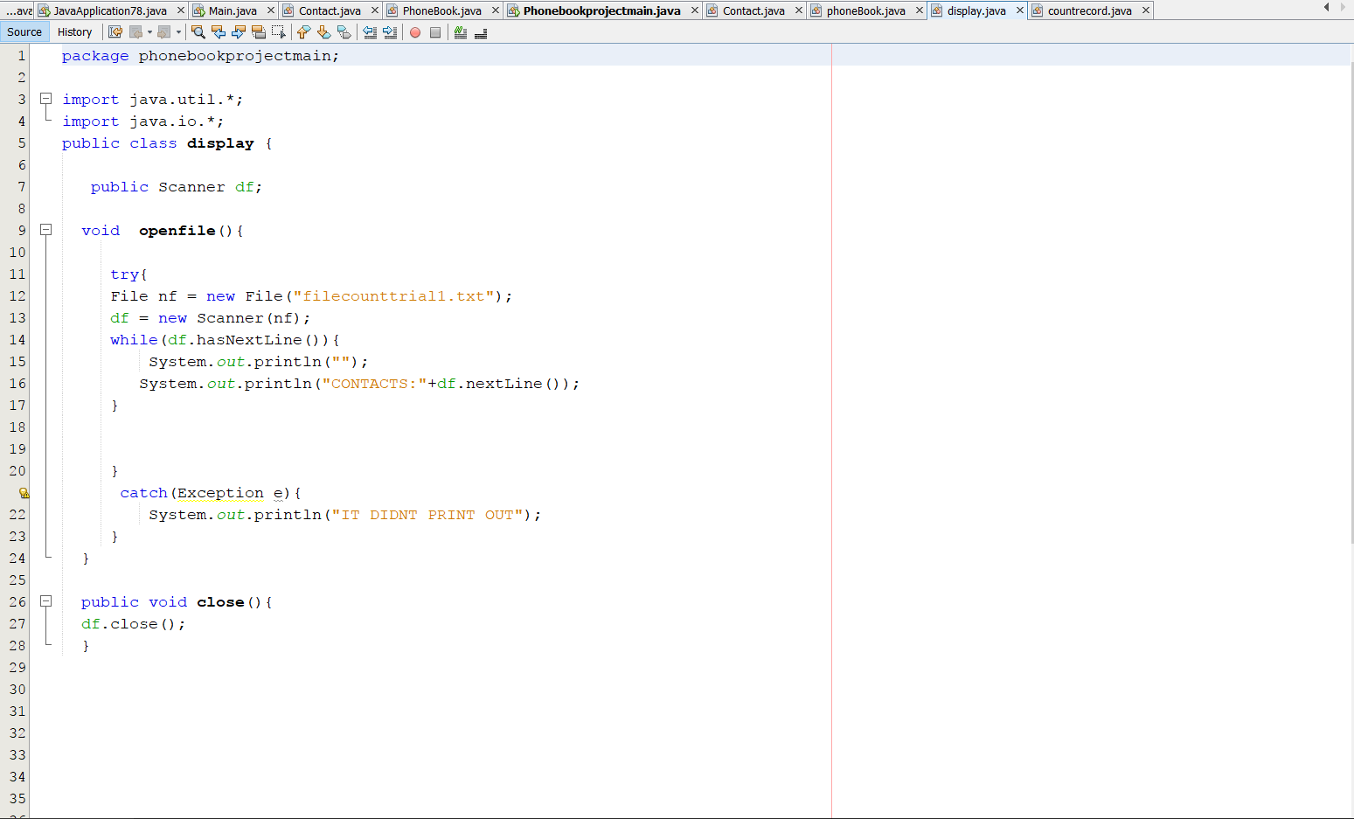

**(SUB-CLASS)**

**Phonebook.java**



**(SUB-CLASS)**

**Display.java**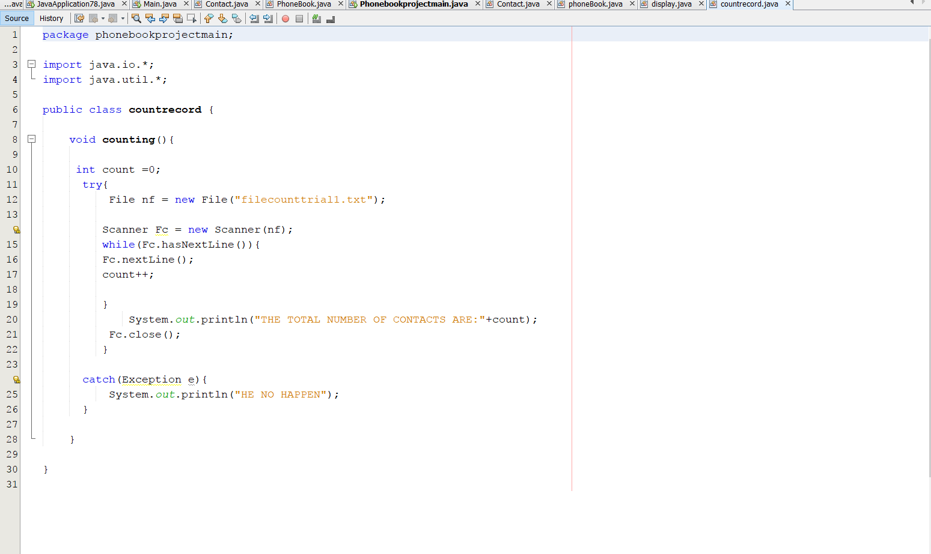

**(SUB-CLASS)**

**Countrecord.java**

**CONCLUSION**

This report presents an introduction to Java and how Java inbuilt file method is used. Java Application development in NetBeans IDE has been explained.

As project creators, we take great pleasure in the method in which we approached the way we did the projects by carrying out research as to how java IDE can be used in the relationship with carrying out external files. The unique and ambitious nature for our project has been an incredibly rewarding experience, but most importantly, it has given us a tremendous boost in the way we code and our programming thinking and approach.

**REFERENCES**

Object-Oriented Programming<https://www.oracle.com/java/technologies/oop.html>

Java Interfaces <http://tutorials.jenkov.com/java/interfaces.html>

Java Project Documentation Guidelines <http://staff.um.edu.mt/__data/assets/pdf_file/0004/58747/docguide.pdf>

JavaTM Platform, Standard Edition 8 API Specification

<https://docs.oracle.com/javase/8/docs/api/>

**User MANUAL**

For the project to run, you have to use the following software’s and their installation is as will be described below:

* Java Development Kit (JDK)
* NetBeans IDE

**Java Development Kit (JDK) Installation**

**Step 1:** Double click the JDK downloaded file, the executable extracts the required contents to the temporary directory and then User account Control screen appears. On the User accountControl, they will ask “Do you want to allow this app to make changes to your device?” click the yes button.

**Step 2:** The setup screen appears, click next.

**Step 3:** The custom setup screen appears, click on the change button to change installation directory. Then click next. After clicking “next” button installation begins.

**Step 4:** Once the installation is finished it shows you the final screen indications of success.

**NetBeans IDE Installation**

1. After the download completes, run the installer. Double-click the installer file to run it.
2. At the Welcome page of the NetBeans IDE Installer, click Next.
3. On the license agreement page read and accept the license, then click next.
4. At the NetBeans IDE installation page, do the following:

- Accept the default installation directory for the NetBeans IDE or specify another directory. The installation directory must be empty and the user profile you are using to run the installer must have read the permissions for this directory.

- Accept the default JDK installation to use with the NetBeans IDE or select a different installation from the drop-down list. If the installation wizard did not find a compatible JDK installation to use with the NetBeans IDE,then your JDK is not installed in the default location. In this case, specify the path to an installed JDK and click Next, or cancel current installation. After installing the required JDK version you can restart the installation.  
**5.** Click Install to begin the installation.